Strategy execution
- Recap – eHarmony failed to successfully differentiate itself from competitors as they didn’t generate more revenue per customer. We learned about the need to manage quality of platform. Who do you let on to the platform and then how do you manage their interactions
  - eHarmony faced these trade-offs all the time – needed to maintain exclusivity and proprietary
  - React immediately to competitors due to the nature of platforms. Deprive them of oxygen.

Acer case
- Never had access to the same capital, pool of highly skilled labour and general ecosystems that Western case studies had.
- Decision to be made is about Aspire computer – should the CEO give the computer a green light or red light?
- What do they need in place to pull this off? Whether an organisation can do something depends on how well you understand it
- Initial strategy was selling a variety of products. Focus on the customer.
  - However too much focus is bad e.g. manufacturers facing customer demands for a customised product. This would require a whole new line, less cost-effective.
  - Lego ramped up from 4,000 components to 8,000 components. Increases risk where products fail e.g. wasted capacity, machinery and inventory. Highlights the importance of sales forecasts to efficiency operations.
  - You can’t go out and please every single customer
- They then focused on early expansion through decentralisation and joint ventures to gradually expand. They had a regional focus on smaller markets in Asia where the big giants were not focused on.
- Between 76 and 86 they maintained flexibility through a lack of bureaucracy, small size, autonomy to workers through a familial culture (pillar 2), frugality (pillar 3), flat hierarchy
Was it a good idea to go public?
- Lots of companies prevent employees selling shares straight away
- Lot more stakeholders who need to satisfy so focus becomes more short-sighted and it becomes harder to do things the way you want to do them and harder to retain customer-centricity. Shareholders less forgiving of mistakes.
- Less risk-taking behaviour, maybe less attractive to young engineers seeking autonomy to innovate.
- Culture of frugality goes.
- Brand exposure is expensive.

Why hire Leonard Liu as CEO?
- Taiwanese – more sensitive to local culture which was the culture of almost all employees
- Shih didn’t have enough knowledge of USA and other big markets – he had always been based in Taiwan. Liu had spent time in the US.
- Once he assumed charge Liu made each unit accountable for profitability, this discouraged experimentation. It removes the lovey-dovey culture. SBUs (strategic business units) in Taiwan and RBUs (regional business units) around the world.
  - SBUs are in charge of product development and design
  - RBUs develop distribution channels
  - Each one responsible for profit and loss. Stress levels rose
- When profits dropped he started to fire a lot of people. This happened due to falling barriers to entry due to IBMs open architecture strategy, and firms started competing on price. As things became commoditised and profits fell
  - Laid off 30% of workforce. Asked unit heads to identify bottom 30% of workers
  - Can damage morale and increase workload of remaining workers
  - First people to leave during a tailspin are the top talents, because they have other options. This can decrease quality of workers.
  - Need control systems to monitor performance, need balance score cards to show employees how their performance will be measured
- This is what Liu was supposed to bring from IBM. New CEOs think they are appointed to fix the company, so they start looking for problems to fix. Liu overlooked the factors behind the company’s success – this is the baby. Having no focus on what’s working leads to throwing the baby out with the bathwater.
  - Danger of bringing someone in from a bigger company is they can overlook what needs to be protected in your company
- Liu fired and Shih took over again. Within a year it was making profits again. He went on a tour of the company around the world, a listening tour, he comes back and formulates a strategy.
- Product lifecycles are shortening so we need to be strict with deadlines
  - Parable / analogy – communication is very important.
  - Acer 3-2-1 3 months for planning, 2 for selling, 1 for phase out
  - One goal: to halve inventory
- Strategy is about adapting to the environment – environment is short life cycle so we adapt by decreasing inventory and speeding up. But he lets the organisation come up with solutions – fly time-sensitive components and ship others to RBUs. Reduce number of SKUs in inventory by using a chip-up approach.
  - Able to inspire the company to find solutions. Employees willing to work for him and trust in him.
  - Now Acer America tells him they want to launch their own computer
- Stan Shih smile curve. Bubble on the left is SBUs where R&D takes place, bubble on the right is RBUs.
  - SBUs add value through development, RBUs do so through marketing and distribution
  - Acer America wants to do both
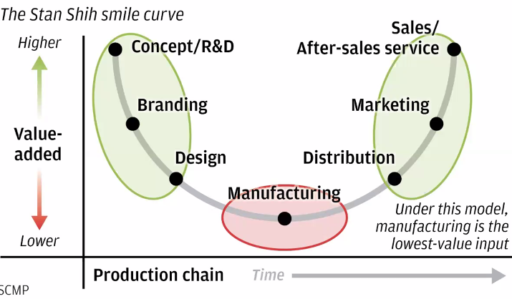
- Aspire given green light after commitment from SBU heads. 4 SBU engineers from Taiwan sent to CALI. Huge advertising budget allocated. Marketing adapted regionally and different configurations worldwide. Aspire doubled AC usual monthly sales.
- Customers started discovering technical problems. Pinning down responsibility for malfunction was hard due to adaptions. Tensions between RBUs and SBUs grew.
- Product wasn’t compatible with structure. Organisation is the vehicle on which strategy moves. Particular vehicles perform in particular ways. Bringing about a shift in strategy requires reorganisation.
- SBUs did all R&D in Taiwan, with global rollout to RBUs who tailored it to local tastes. Mixing workloads between the two damaged the well-oiled machine. Sending the engineers wasn’t enough to avoid this.
- Supply chain links make it hard to just move a factory or function.
- Acer was rich enough to absorb this shock and improve the product, most companies aren’t
- Do we have the structure to run this new strategy?
Review
- Why are organisations successful? Two reaonss – it’s the industry, need positioning in this industry. Second is you have unique competencies.
  - Generic strategies of cost leadership and differentiation
  - Walmart cost leadership, Apple differentiation (twist was that it was also about platforms, which challenged the existing model of Porter’s 5 forces which is premised on industry boundaries. Platforms show there are no boundaries).
- Netowrk effects characterise more and more idnsutries. Comp dynamics are fundamentally different here. Blue Ocean strtagey breaks the price-vlaue trade-off
  - Ikea invented a new category
- How many businesses should a company be in? GE said they created synergies across business, but number of conglomerates is mostly concentrated in emerging markets. This is because they create value by filling institution voids of contracting, Conglomerates in thw West are rising again but they are platform
- Disruptive changes in the environment – incumbents struggle (Kodak) despite having resources because. Car exercise shows the bigger the brand the harder the response because you try to preserve your position and leverage your brand. Its not about tech, its how you position your tech in the ecosystem – becomes the central node, own the platform or own the customer base to capture value
- Rules of governance – access and interaction are important in platforms
- Structure is important – it is the vehicle on which strategy runs.

Reading

Acer case study

Laying the foundations
- Founded in Taiwan in 1976, aiming to promote the application of emerging microprocessor technology. Grew by grasping all opportunities – “we will sell anything but our wives”
- Capital constrained so cultural norm of frugality. Leased just enough space for current needs and paid modest salaries but offered key employees equity in subsidiary companies.
  - Frugality – customers first, employees second, shareholders third.
  - Avoided using debt
- Substantial delegation of decision-making, informal manner, laissez-faire approach. Close-knit familial culture, but Shih combated complacency and entitlement

Birth of the dragon dream
- In the mid-1980s sales were doubling each year and a 10-year Dragon dreams plan was announced. After the firm’s 10-year anniversary, senior figures were invited to identify and evaluate company culture and philosophies. Mid-level managers also asked to review and vote on key principles which should carry the company forward. Outcome was four values:
  - Human nature is essentially good
  - Commitment to fundamental pragmatism and accountability in all business affairs
  - Placing the customer first
  - A norm of pooling effort and sharing knowledge

Going public as Acer
- Growing visibility lead to a US company of the same name alleging trademark infringement. Had to rebrand as Acer – implied highest value in cards and meant the firm would be first in alphabetical listings.
- Success of its 32-bit PC convinced Acer that its rapid product development was a continuing source of competitive advantage. With planned aggressive international expansion, the imperative to maintain its technological edge created investment needs exceeding Acer’s internal financing capabilities.
  - Shih examined the possibility of a public offering. Negotiated a complex multi-tier financing which involved private investment and an IPO. Acer employees held 65% of equity, with the Shihs’ share being 25%
  - Acer raised $88m, with stock prices doubling from their listing price.

Professionalisation of acer
- IPO dealt with capital shortage, but Shih was worried about a management shortage caused by rapid growth. From 1985 onwards he brought in a dozen top-level execs and 100 mid-level managers. This generated significant turnover for the first time as staff felt these “paratroopers” were intruders who did not understand Acer’s culture, only its soaring stock
- Internally grown managers lacked experience, so paratroopers had to implement offshore expansion plans. Acer acquired a US manufacturer of minicomputers. This failed due to market decline. Competitive dynamics of the PC market shifted, with dramatic price reductions due to Dell’s direct sales model. Acer’s margins fell

- Rebuilding the base
- Acer America and the Aspire
- Stan Shih’s decisions

Secrets to successful strategy execution

Introduction
- Execution fails when enterprises go straight to restructuring and neglect decision rights and information flow, the most powerful drivers of effectiveness
  - Execution important as you need to be able to deliver you intended brilliant strategy
  - Employees and 3 out of 5 firms rated their organisation as weak at execution
- Execution is the result of thousands of decisions made by employees based on available information and self-interest. Four building blocks used to influence these decisions
  - Clarify decision rights
  - Design information flows
  - Align motivators
  - Make changes to structure
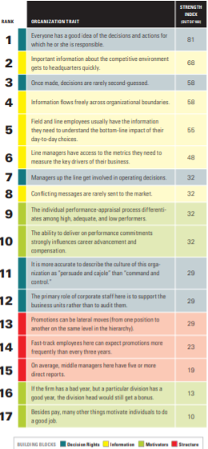
- Focusing on structure first can give short-term efficiency gains, but addresses only the symptoms of dysfunction, not its root causes. According to the authors, structure’s importance is 25, compared to around 50 for information and decisions rates (scale = 100)

Elements of strong execution
- 17 traits of organisational effectiveness are correlated to one or more of the 4 building blocks which enable effective execution. They are ranked by importance, allowing individuals to assess to overall execution capabilities of their organisation.
- First 8 traits map directly to decision rights and information, and only 3 of lower importance relate to structure.

Top 5 traits
- Everyone has a good idea of the decisions and actions for which they are responsible. Blurring of decision rights is common as a company matures – as companies grow, executives come and go, bringing and taking different expectation. Over time the approval process becomes murky
  - One company had people making conflicting decisions, hard to find anyone below CEO who felt accountable for profitability. Decisions made by divisional and geographic leaders routinely overridden by functional leaders. Only CEO and executive team had the discretion to resolve disputes
  - New CEO redefined divisions to focus on customers and designated clear profit accountability to the divisions, also giving them authority to draw upon functional activities.

- Information about the competitive environment gets to HQ quickly. HQ identifies patterns throughout divisions and regions, but requires accurate/fresh market intelligence. Otherwise imposes its own agenda rather than defer to operations focused on the customer.
  - Caterpillar’s decisions rights were hoarded at the top by HQ, but the information needed to make these decisions resided with sales managers. Information transfer was slow up and down functional silos. Information which did reach the top had been whitewashed and varnished. Cut off from market information, senior execs focused internally and overanalysed internal workings, resulting in missed opportunities in fast-moving markets
  - The way to ensure the right information flowed to HQ was to delegate operational responsibility to people closer to the action, allowing execs to focus on global strategic issues. Functional general offices were shut down and the expertise of people in them were parcelled out into new business units. Decentralised decision rights gave units control over market decisions, allowing ROA to be a universal measure of success. This accurate, up-to-date and directly comparable information allowed smart choices and trade-offs.
- Once made, decisions are rarely second-guessed.
- Information flows freely across organisational boundaries. When information cannot flow horizontally, units behave like silos, forfeiting EoS and the transfer of best practices. Also loses the ability to develop managers well-versed in all aspects of the company’s operations.
- Employees have the information necessary to understand the impact of their choices. Rational decision-making is bounded by available information. If managers don’t understand the cost of pursuing an incremental dollar in revenue, they will always pursue it. Manager’s cant be faulted even if, in light of full information, the decision is wrong.
  - Financial services client separated bankers selling loans from support groups who did risk assessments, placing them in different locations. Company failed to implement the necessary information and motivation links, so the two groups pursued competing goals. For example, bankers would routinely sell highly customised one-off deals to clients that cost the company more than they generated in revenues.
  - Without sufficient information, sales staff through support staff were sabotaging their deals. Support staff considered front-end staff to be cowboys. At the end of the year, operational costs had increased, often erasing the profit from these transactions.
  - Information misalignment addressed by adopting a smart customisation approach to sales. End-to-end process used in the majority of deals standardised, and allowed for customisation only in select circumstances, in which there were clear analytical support tools to arm bankers with accurate cost information

Creating a transformation programme
- Four building blocks to improve strategy execution – decision rights, information, structure and motivators – are closely linked. Unclear decision rights paralyse info and divorce performance from rewards. Blocking information leads to poor decisions and a reinforcement of structural silos
  - Organisations face unique sets of internal and external variables, so no one solution

